Ops Admin
Monday:
APT Report (Friday, Sunday, Weekly)
Lucas Picks(Saturday Monday)
VIP Check
Loader Report (Friday Old &Sunday New)
Loader report(weekly)
Daily Ops Stats
Catch weight changes
Device tracker
Shorts & Mispicks J & I, DSM, checker errors, daily ops
Lucas Batch not called in not including NY and PA
Lucas No PIR 3 above
Checker Report
Mena Inventory(3:00pm)
APT Selector batch start and end time
Tuesday:
APT Report
Lucas Picks
VIP Check
Loader Report
Daily Ops Stats
Catch weight changes
Device tracker
Bids Credits
Shorts & Mispicks J & I, DSM, checker errors, daily ops
Lucas Batch not called in not including NY and PA
Lucas No PIR 3 above
Checker Report
APT Selector batch start and end time
Wednesday:
APT Report
Lucas Picks
VIP Check
Loader Report
Daily Ops Stats
Device tracker
Catch weight changes
Selector Progression Chart
Night kpis(1:00pm)
Transportation KPI(1:00pm)
Shorts & Mispicks J & I, DSM, checker errors, daily ops
Lucas Batch not called in not including NY and PA
Lucas No PIR 3 above
Checker Report
APT Selector batch start and end time
Thursday:
APT Report
Lucas Picks
VIP Check
Loader Report
Daily Ops Stats
Catch weight changes
Device tracker
Driver Overview
Weekly ops performance by division
Shorts & Mispicks J & I, DSM, checker errors, daily ops
Lucas Batch not called in not including NY and PA
Lucas No PIR 3 above
Checker Report
APT Selector batch start and end time
Friday:
APT Report
Lucas Picks
VIP Check
Loader Report
Daily Ops Stats
Catch weight changes
Device tracker
Shorts & Mispicks J & I, DSM, checker errors, daily ops
Lucas Batch not called in not including NY and PA
Lucas No PIR 3 above
Checker Report
APT Selector batch start and end time

Short answers
Reprinting a live invoice: telenet, 225 printer number is 3
Reprinting a closed invoice: telenet 7171 I invoice number printer 3
Finding older credits: 75 cust number
Inv Adjustments 512item number T x for all A for adjustments
Find errors DUG71

Routes per warehouse
Wayne IDs
02-98
A-F
H-M
Q
T-U
PA IDs
P
R
S
N
O
NY IDs
G
W
Y
X
Z
01 - is for pick ups/will calls for all divisions
78 is a holding pattern for unrouted orders. All delivery orders are route 78 until they are assigned a route. Routing checks route 78 at the end of routing nightly to confirm there is nothing still in route 78 that needs to be assigned, because if so it will not be picked/delivered
99 is a pick and stage route ID used in Wayne
276 live mispicks report

OPS error
Weight call in issues
If there are issues, email Kudjoe Daniel White and Clauder
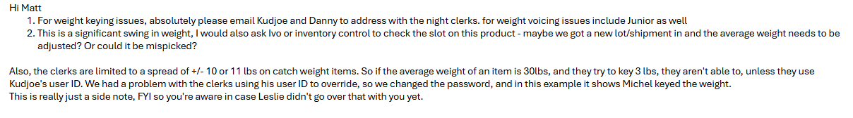Mispick
FWD message to Inventory Control CC ops error
Msg:
Can you check the slot for item #XXXXXXX
We sent Y
Example
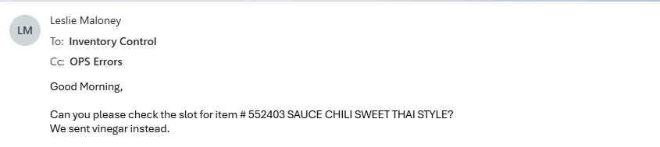
To get the item number and description log into Telenet 51type in the item number, copy and paste the description into the email
If the Item is slotted correctly
Forward the response from inventory to the sales rep CC ops errors
Msg:
Product slotted correctly. This was a mispick and will be addressed.
If item is slotted correctly but slot is mixed, cc Samantha cuesta so the selector is not penalized for a mispick that’s not his fault
In telenet 27364 put in the date, route, and item
Copy the picker and item info for the next email
Then forward the response from inventory to the corresponding night manager (dry, freezer, or cooler) CC Ops errors, phillip rodriguez, kudjoe larbi, and Daniel white
MSG:
We picked x from slot a instead of y from slot b
Paste the telenet info for the picker and item

Example:

If the item is slotted incorrectly
FWD the response from inventory to the sales rep CC ops errors
Items slotted incorrectly, it has since been fixed.

Damage/Quality/Expiration
FWD Item to inventory control CC ops errors & produce (if it is a produce item)
Customer received (issue) products, can you please check item #(item number) for (issue)
FWD their response to the sales associate with a brief summary of what happened.

Shorts
Usually you can not follow up on shorts for a couple days after the delivery date as the invoices, and driver return forms need to be filed and uploaded to the system.
First check Lucas/Lucas pick report to see if the item was confirmed picked. Use item & order number to confirm.
Next check the driver return reports in V:\Route Return sheets use the date and route number to find the form. If the email does not include the route number, use telecom to look up the route number with the order/invoice number 211order/invoice number example on next page(A). Last check the invoice to see if the item was checked off and signed for use the archive picker with the invoice number to see the invoice find the item in question and whether it was marked off. A small check usually denotes the item was checked off.
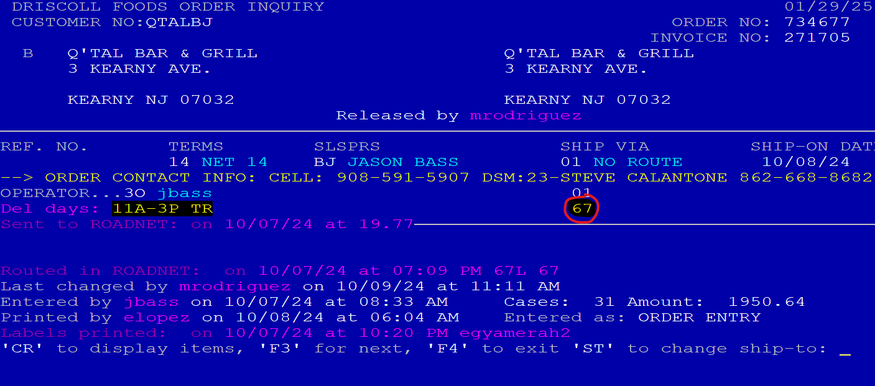
Email: you can reply to the sales rep letting them know if the item was confirmed picked in lucas, whether it was on the driver return report, and if it was checked off on the invoice. As well as screenshots of all 3 with the item in question highlighted.
EX:
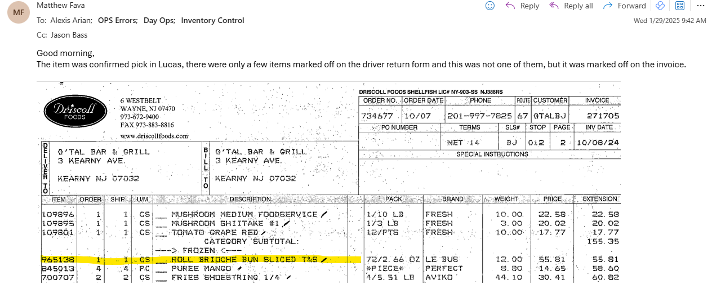
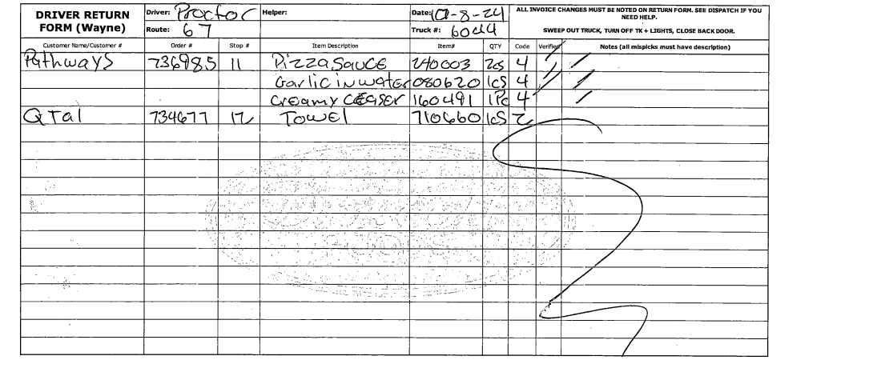

APT report
Done Daily for the day before also done weekly for Sun-FRI of the week before
On Monday run for Friday, Sunday, and the week
You should have 6 daily and 1 weekly report per week
APT by agent folder on desktop
Log in
Wayne
Top left of screen Reports reports menu
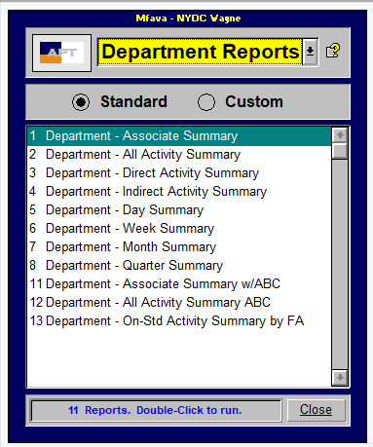
Department Reports
Department – Associate Summary

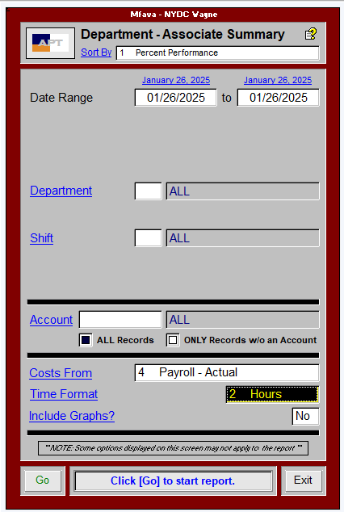

Sort by Percent Performance
Date range: date you want to run done for the day before Ex: on the 27th you would run the 26th
Costs from: 4. Payroll – Actual
Time format: 2. Hours
Go to start report
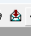 To export report

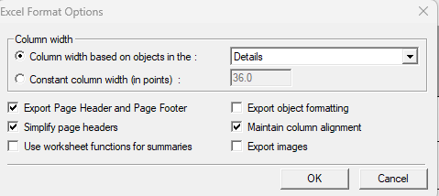
Format:MS Excel 97-2000(data only) Check off maintain column aligment
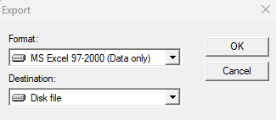

Save the file on your desktop it will be deleted after it is used.
Highlight column A (only numbers ignore the first two rows and last 2 rows)
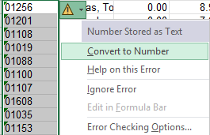
Click on the triangle and convert to numbers

Paste these items as values into the template APT report located here(O:\Ops\Night reports\APT Daily and Weekly\2025) into the first 2 columns
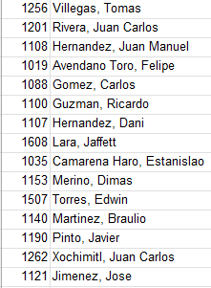
Copy col C to P ignoring the first and last 2 rows
Paste into apt report starting Col D
Copy row with dept #01 total from the report you ran into bottom of apt report
Name Tab in APT report with Weekday, Month Date
Save As
MMDDYY APT Report in the correct month folder
Email to Night ops
CC Samantha Cuesta, Jarred Ferrer Phillip Rodriguez, Alejandro Texca, Kudjoe Larbi, Clauder Jimenez
Subject: APT Report MMDDYY
Msg
Please see attached for the APT report for Weekday, Date
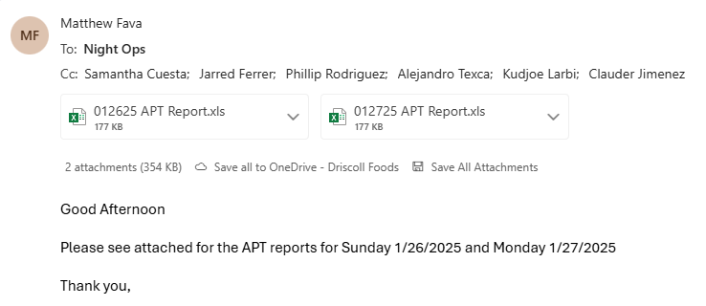

Lucas Picks
Daily
On Monday do for Saturday and Monday dates
If you load Lucas and get a Microsoft silverlite notification go to the browser settings and add lucas to the internet explorer mode pages
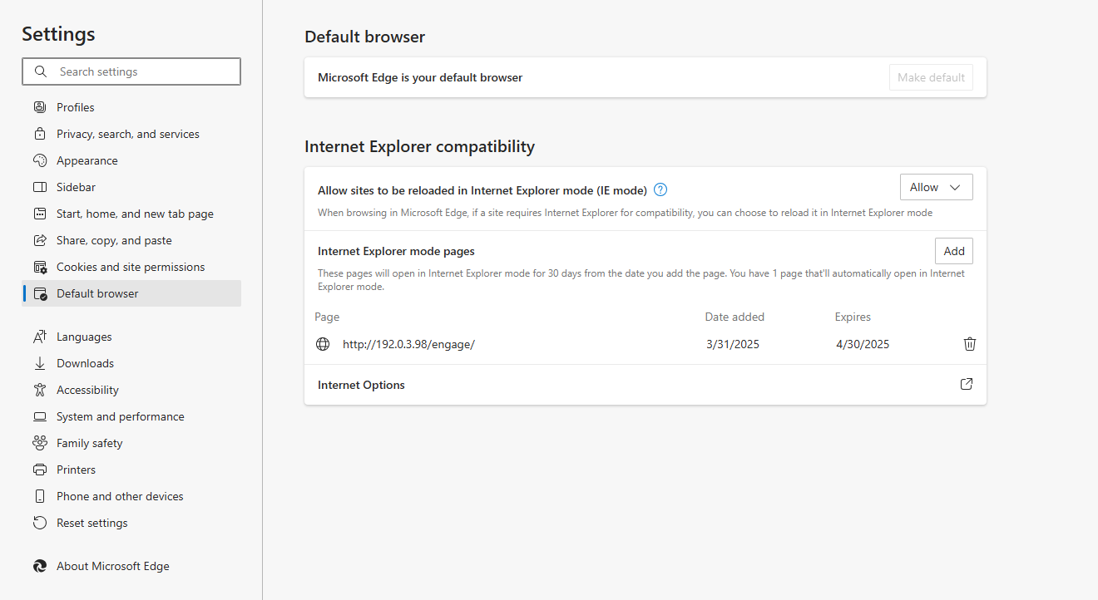
Layout and saved files are in O:\Ops\Night reports\Lucas saved files are in folder 2025(or whatever year it is)
Open lucas go to picklines
Make sure all is unfiltered hit the unfilter button
Click on Ship date filter then custom your start date will be the day before and your end date will be the day of the report being ran.
On Monday run for Saturday and Monday

The example below is being run for Tuesday, January 28, 2025
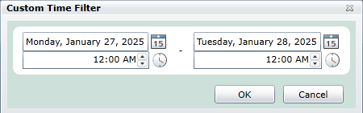
Export excel
Button in bottom right corner
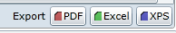
Records from 1 to X round total records up to nearest 1000, number of records can be found below the export panel
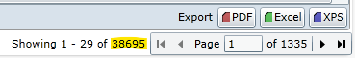
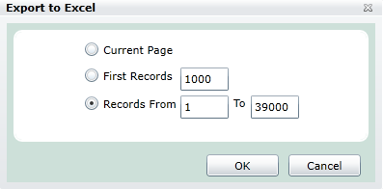
Copy all information below the header line into the layout folder use option on the right paste match destination formatting
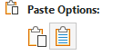
Highlight all information in col G below the header line and shift to the right
Hit insert, Shift cells right
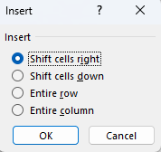

In G2 use the concat formula to combine D2 E2 and F2 with spaces between.
=CONCAT(D2," ",E2," ",F2)
Drag formula down to bottom of col or double tap the square in the bottom right corner
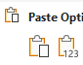
Copy all those cells and paste as values, clipboard with 123
Hide Col G, click on the G col right click and hit hide

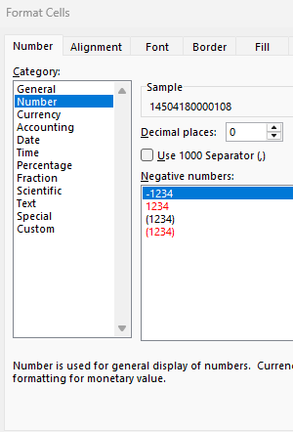
Go to Column S Highlight all below header line
Right click go to format cells under category choose number and make sure there are 0 decimal places

Save As follow formatting of the previous Date in folder labeled 2025(or whatever year it is)

Email to Transportation
CC: Kathy taormina, Samantha Cuesta, Jarred Ferrer, Alejandro Texca, Andrea Cuesta, Andrew Herasimtschuk, Claduer Jimenez
Subject Lucas Picks “dates”
Msg:
Good morning,
Please see attached for the lucas picks report for
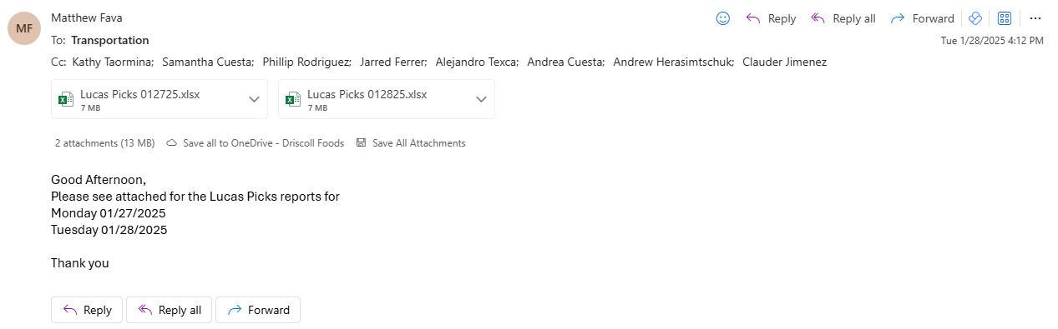
Weekday, Month day year

VIP Report
Start around 5pmish
Telecom 3021 use tomorrows date, these reports are emailed to you
VIP Alert
VIP Orders
Open the VIP + Audits template in the corresponding year in O:\Ops\Audits
Save with tomorrows date, change the date in the report
VIP Alert copy and paste into report in 1 column paste special, text
Hover the first col go to data text to columns, fixed with take the 2nd col and put it in col G the other col in col H
Extract the Customer code and order code from that info type in the next two columns the 2nd code is the customer code the 1st is the order code.
Copy those two columns over to column G&H sort g&h az
Select A D G H use conditional formatting to duplicate. Delete any set of 2 codes that are not highlighted.
If a customer has multiple non duplicate orders add rows to the report and add those orders in copy all information
Delete any of the special routes with no instructions.
For Jarreds sections open telenet 51 enter the Fry code. Left arrow down arrow, add the customer #, name, and order number
CAR
You will receive CAR emails throughout the day from Ashley Rodriguez put the customer number name reason and order # to the report.
It will be the same process for new customer alerts
Special cases can be added to the new customer alert section, add the customer # name, order number and notes, the reason will be special request Highlight and special requests.
There is a VIP Audits accounts email template in the folder O:\Ops\Audits double click this to open. Copy all the information from the audit report and paste it into the email. Save the VIP report as a PDF. Attach the PDF, VIP Alerts, and VIP Orders files to the email.
Attach all the Car, New customer, and Special alert emails to this email. If there are special requests draw attention to it in the email.
EX:
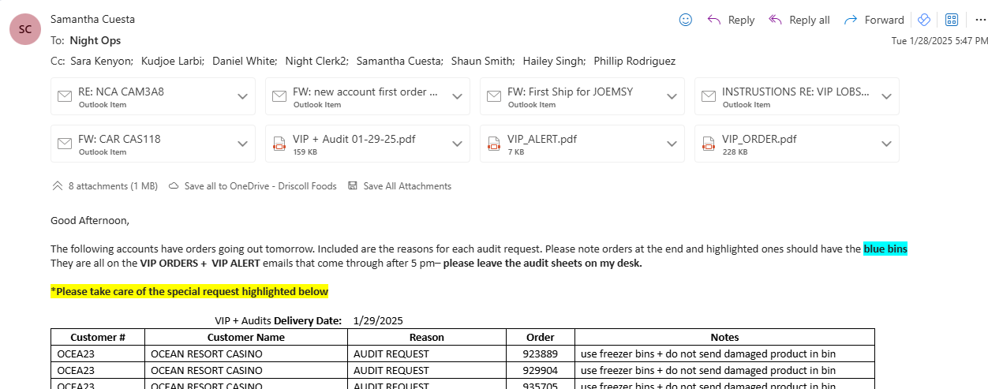

VIP CT Report
At 3:00pm run the VIP report route starts with an I
Telecom 3021 use tomorrows date, these reports are emailed to you
Email the VIP Alert file to Night ops, Shaun smith, Sara Kenyon, Kudjoe, Daniel White, Phillip Rodriguez
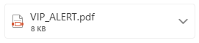
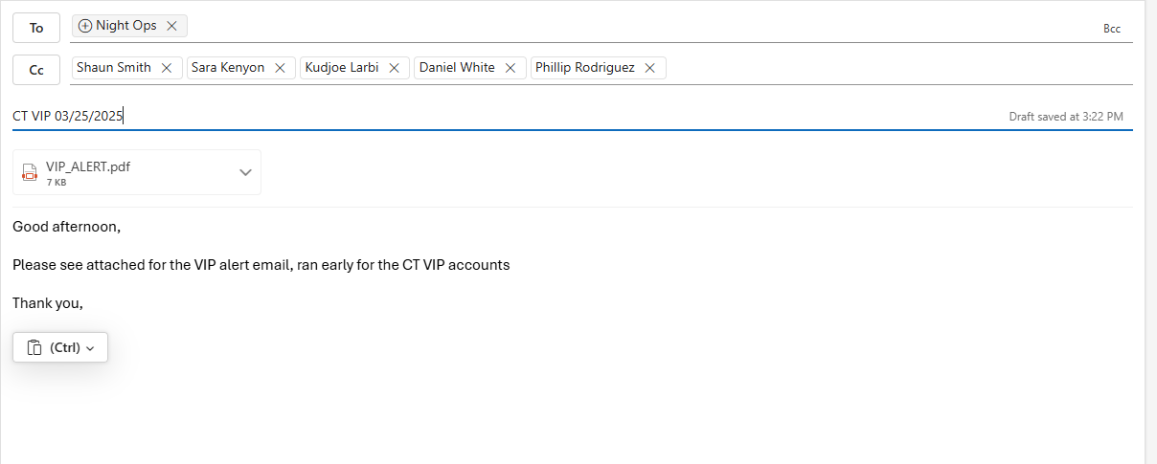
VIP CHECK
After completing the APT and Lucas reports
You should have a pile of VIP sheets on your desk in the morning
You will mainly be checking for shorts and weighted items, when you see a weighted item you have to add all the individual weights together to make sure they add up to what’s in telnet and what’s on the VIP Sheet
For shorts you are just checking to make sure the item was adjusted in telnet the same as it was on the VIP sheet.
Open Telnet 23
Order number click left until you get this message at the bottom, ? enter type in the item number
Once you go through all the sheets, scan all the sheets into your computer. Save them with todays date Ex 02-03-2025
You save them in the VIP + Audits folder under the scans folder in the correct month

Loader Report

O:\Ops Management\Maintenance\Night\Loaders\Loader Productivity\Tracking Reports
Weekly loading Reports 2025 loading report week template
Save for the correct week, after saving rename each tab between the days of the week with the days of the week
Loading report should be emailed from Night Clerk
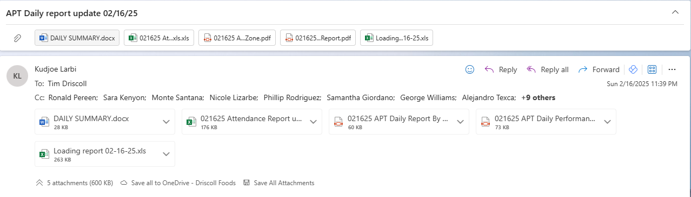
Loading report “date”.xls
Open this report, go to the bottom cut and paste col B-E the extra notes at the bottom to the right of the page in col AD-AG
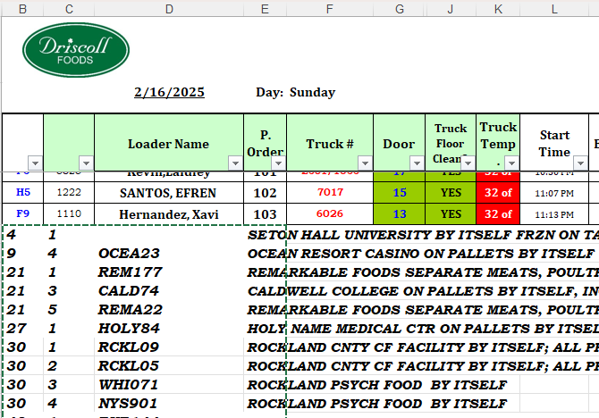
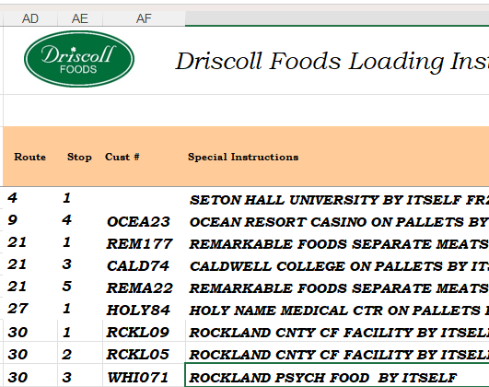
Make sure every cel in col AB has the countif formula
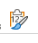
Copy and paste all the information from the loading report into the into the weekly loading report using paste values and formatting
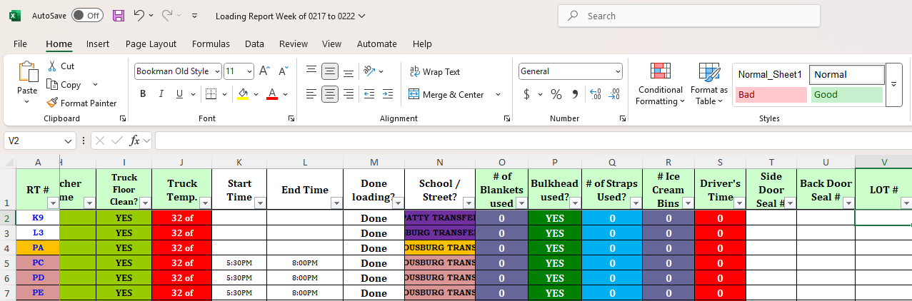

For Fridays select all under the header in COL G, add two columns, and you will not need a checking sheet for the date tab

Select all the cells under Col V header LOT#, delete all and shift cells to the left
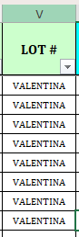It should look like this at the top instead of blank cells
Copy all the route numbers from Col A and paste it into the date tab col A as values only
Get the pallet by summary route for the date, copy all and paste them into col G&H
The rest of the columns should automatically fill out
Make sure Cols B, C, D, E have the formulas filled out
Get the checking sheet from Night clerk (day before)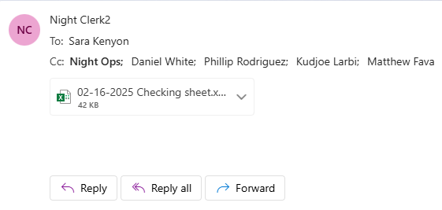
Put a filter on Row 7, filter name without blanks
Copy all routes from col A and paste them into the date tab in the loading report weekly Col O
Highlight col A and O and use conditional formatting duplicate cells
Sort col A by highlight color red up top
Any rows that have Col A highlighted go to route E and if the value is 0 change it to a 1 and change the text color to red

Click on the pivot table then go to the pivot table analyze and change data source, change it to col A-E, then filter and include all the numbers minus blanks, 0, and none
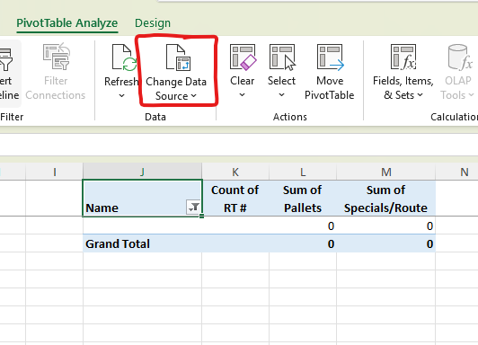
Loader bonus tracker
O:\Ops Management\Maintenance\Night\Loaders\Loader Productivity\Tracking Reports\Loader Bonus\2025
Use template to create this weeks report save for the end of this week
Copy id from the first col of the pivot table past into loader bonus sheet, employee should fill out
Copy routes pallets and specials and paste into loader bonus sheet

Take the IDs from the pivot table on the date tab and paste them into sheet 1 on the loader bonus sheet Put the day of the week next to it
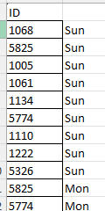
Find out what gets attached to the email

Selector Progression Chart
This report will always be for the week that ended before
After sending will be printed out give to phillip rodriguez or kudjoe you will get them back signed go through and scan them and put them into the folder of the day they are in
O:\Ops Management\Maintenance\Reports\Shorts and Mispicks\Performance Productivity\Night Warehouse
Open and save a new copy of each report in the year and month, with the new end of week
Open the errors file delete all info inside save as errors WE last weeks date
O:\Ops Management\Maintenance\Night\Selector Incentive\DF SI\2025
Go to the sheet that says Final
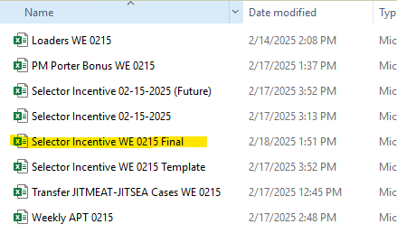
Go to the Weekly totals tab, copy COL A,B,C,D( ID, employee name, temp zone, Hire date) and paste them into the Errors sheet
Copy Col I,J,K(Shorts, mispicks, damages) from weekly totals tab and paste into errors sheet
Open weekly APT report, copy over ID, employee name, date of hire, temp zone, on standard hours, earned hours, and cases to the Progression APT sheet

On the Progression use a VLOOKUP for the shorts, mispicks, damages and temp zone
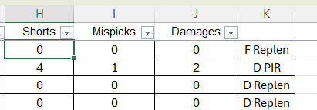
Hide col E through J, make sure COL D matches COL K if you change it make the text red
Delete Rows where it says, Loader, Replen, or mentor
This sheet is done you can delete COL K and make sure all values are numbers and not formulas

Selector Progression Sheet
If you have not already done save a new copy for this week
As you go through tab by tab copy the formulas over to the next week and input the info from the Progression sheet.
When you are done with a selector highlight the name and go to the next on
If someone is not on the progression chart but is on the selector progression chat hide the tab
If someone is not on the selector progression chart but on the progression sheet unhide the tab
If a trainee is done with their entire sheet and there is no room to input more data, make a copy of the intermediate sheet next to their name input their personal info at the top delete the old tab and continue as normal. If there is a new hire, make a new tab using the Trainee tab.
If an intermediate or advanced tab is full and you need to add more data for this week, delete all info inside and continue as normal
Whenever deleting info make sure the first col in each chart has the formulas in it

Daily ops stats
O:\Ops Management\Maintenance\Reports\KPIs\2025

Orange boxes are from the dispatch sheet
O:\Ops Management\Maintenance\Driver\DF DI\Dispatch Sheets\Dispatch Sheets 2025
RTs col
Highlight all RTs in col A stop at transfer use count for total, subtract Double RTS and BHS from ops stats sheet
BHs = BHS in ops stats
transfers
Filter route descriptions to include descriptions that include transfer
Clear filter
Straight trucks: Select all in Col H before transfers subtract Double STR in col B ops stats
TT Filter col H by numbers that start with 88,99, or include 5641, 2651,2654, count these and subtract the duplicates and the double TT
Driver helper: Filter Col without blanks select all count
Driver training: go down to the disability section of the dispatch sheet select all in col X tht have training in it
Driver PTO: select anything with vacation or personal time PTO in col X
Same for Call out and NCNS
For extra drivers anything that includes assistant, extra, inhouse
Done with the dispatch sheet
Light grey blue boxes
Open the APT report for the day before so for the 6th you open the APT report for the 5th
At the bottom of the APT report get total cases from col P and PM% from col M
Green Boxes
Use Dug 14 to get inbound cases and pallets for the day warehouse 01
Purple Boxes
Sent over from Frank Bedon Day warehouse attendance report
Use the box in the middle towards the bottom
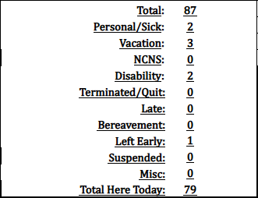
Use Total here today for AM OPS headcount
Vacation + personal for AM PTO
NCNS for AM NCNS
Left Early for AM Left early
Terminate/Quit for AM terminate/quit
Yellow boxes
Email Nightshift Recap from Daniel White/Kudjoe
Use Delivery Date on sheet to determine what row to put it in
Stops for orders Col H
Batches for Col I
Selects head count, total selectors col Z
PM Trainers, total trainers
PTO in scheduled time off, Count
PM C/O, NCNS, S/H in sheet

Dark Blue boxes
O:\Ops Management\Maintenance\Driver\DF DI\Incentive Changes\2025
Select the report for the Week end that your date falls into, filter by the date of the report look for red text if it says accident its for accident, any customer complaint counts for injuries

Grey boxes
Final Reship log email
Get the reships & voids here

White boxes
Fuel
Portal.restalloil.com, ULSD clear total
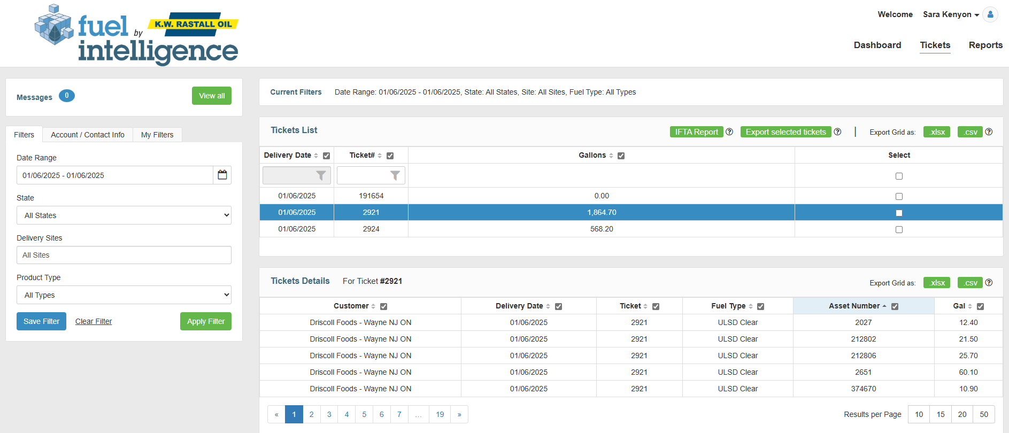
Milage
Intelishift
Date & reports, on-demand reports, state mileage, select all trucks, select for the date go to the last page for total

Email template in folder: Daily Ops stats

For Saturdays a couple things change
The yellow boxes open the APT report highlight all the selector names for selector head count 0 out the rest
Orders go to lucas picks report, highlight all Col create a pivot table, the recommended just hit okay. Order put in rows highlight all for total orders
Batches uncheck orders check assignments highlight all to count

Night KPIs
O:\Ops Management\Maintenance\Reports\KPIs
Use the Night ops KPIs report

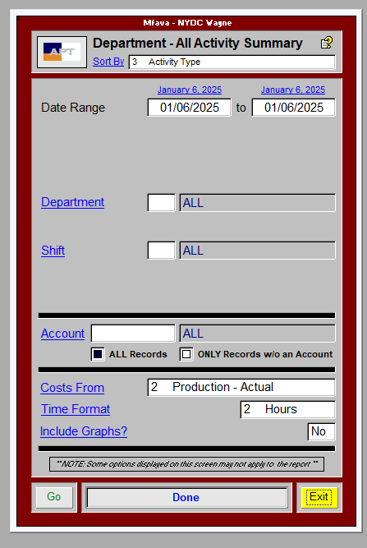
APT Report, for the day before

For each section add together pick and school numbers to get the total
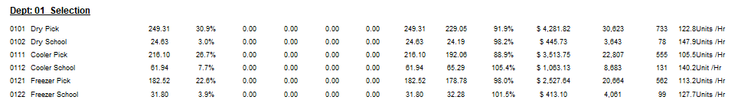
Go to shorts & mispicks report
O:\Ops Management\Maintenance\Reports\Shorts and Mispicks\Weekly
Go to the week that the date you are doing is in
In the wayne by temp zone tab go to the pivot table uncheck picker names, click on date then ungroup
The table should look like this
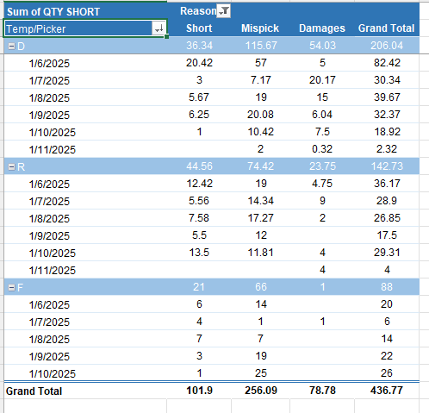

In the recap Q and W tab you will put the hours that come across from the two emails together and put them in the correct week col
Your Report Night Shift Driscoll KPI is ready
Your Report Future Night KPI is ready
For total routes use the loading report highlight col A for the route count for that day
O:\Ops Management\Maintenance\Night\Loaders\Loader Productivity\Tracking Reports\Weekly Loading Report
Use the loader bonus report to get the # of loaders per week and loading errors use the weekly totals tab
Use the weekly APT report to get APT % use performance for the %
Transportation KPIs
O:\Ops Management\Maintenance\Reports\KPIs
Weekly routing numbers report will come across from Andrew V,
You get the stops cases and reships from this report use the weekly totals
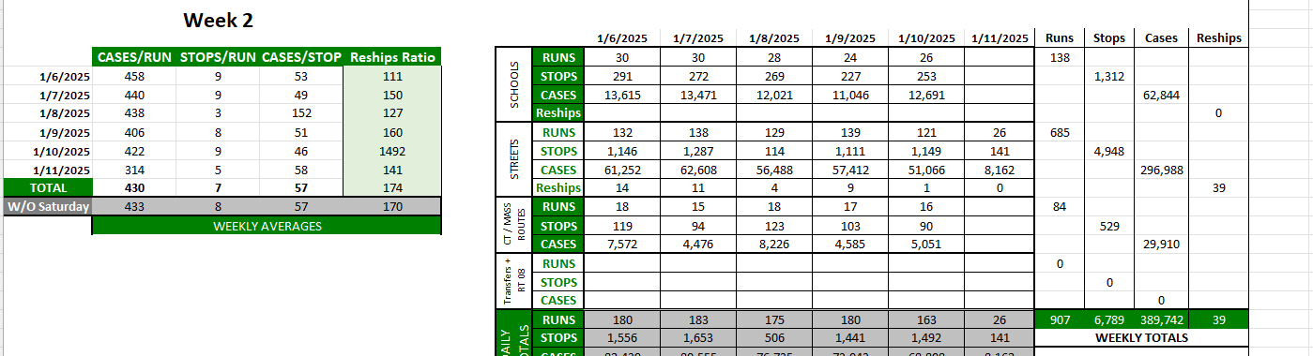

Shorts & mispicks report for short, short/found later, and damages
Driver by supervisor tab, unselect driver name
O:\Ops Management\Maintenance\Reports\Shorts and Mispicks\Weekly\2025\1. January 2025
Driver hours
Driver KPI email
Night shift
Use inteleshift for the week total miles
Data and reports state mileage, select all, select the week (Sun-Sat) you are doing go to last page for total check if its total or adding certain things states together

Device Tracker
O:\Ops\Device Tracker
Start shift tab
Format and unprotect the Sheet, Password is 12345
Sort Assigned number smallest to largest
Update any employee information
To get the information go to telenet 3020 use the ID to get the employees name so you can add it to the employee listing tab
Highlight Cols C&D format check for duplicate values

End shift tab
Unprotect sheet
Sort assigned number smallest to largest
Check Col A for duplicates
Check total scanned on the start and end shift tabs
Format protect both tabs on the sheet

Device Sticker Replacement
O:\Ops\Device Tracker
The Device Tracker TEMPLATE sheet has a hidden tab called devices
Unhide the sheet
When you need to put new stickers on the phones.
You can put either the number, barcode, or both stickers on the phone dependent on whats needed
On the phone open the Lucas Move app, hit the green button in the top right corner, make sure this number matches the number on the sheet if it does you can go ahead and print out your sticker

For the barcode on the label printer, create label FNgo to the bottom hit barcode then type the number in and print it out,
For the device number just go to create label and type the phone number in
Driver overview
O:\Ops Management\Maintenance\Reports\Shorts and Mispicks\Performance Productivity\Drivers
O:\Ops Management\Maintenance\Reports\Shorts and Mispicks\Weekly
O:\Ops Management\Maintenance\Reports\Shorts and Mispicks\Performance Productivity\Drivers\2025\Errors
In the shorts and mispcisk file use the wayne driver error rate tab
Copy ID RT Employee name, from shorts and mispicks sheet, paste into error sheet
Copy hours damage, shorts, shorts found later, & total paste into error sheet
O:\Ops Management\Maintenance\Driver\DF DI\Incentive\2025 incentive breakdown sheet use total weekly data tab
Use a vlookup using RT as the lookup ID
RT over for reships violations and complaints
Reship 89 violations 96 complaints 103
Sheet 2 has all the col numbers for the vlookup

For the overview copy the ID RT and employee name over to the overview along with all the other info needed from the errors sheet
Make sure all the formulas are done for each row all the way to the bottom
Done with the error sheet
For the Daily data tab
Copy & paste ID RT Employee name into daily data tab
DFDI Dispatch sheets
O:\Ops Management\Maintenance\Driver\DF DI\Dispatch Sheets
Week ending sheet

Vlookup RT as the lookup ID, Start at Col B up to Col V on Dispatch sheet
Cases:19 Dock:18 Miles:21
Replace all N/A with 0
On overview and daily data use email template

Driver pickup credits
Email from Jhanfranco Bedon “date” customer pick up report
Red: there was no pick up no credit issued
Yellow: quantity is different use the # of cases on the report
Blue: picked up without pickup slip, send email to the sales person asking for them to submit a credit for the item
Subject: “customer number” driver pick up credit
MSG:
Good afternoon,
Can you please submit a credit for the attached invoice the item was picked up without a pickup form
Thank you,

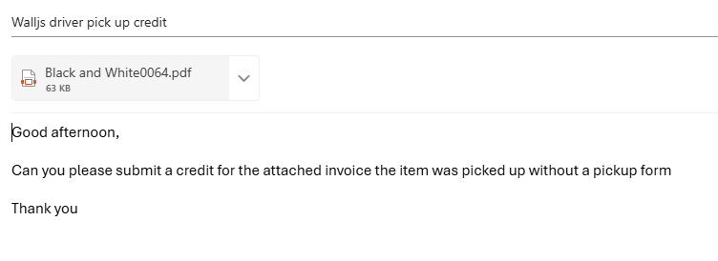
To check sales person in telenet use 31 customer number under sales person

Credits no invoice:
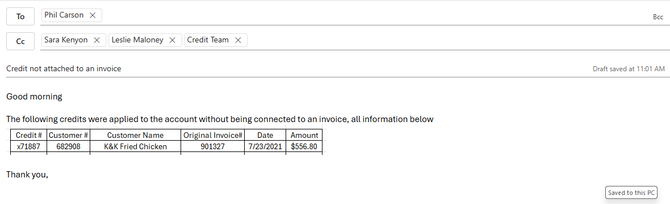
Catch weight updates
James will send out a catch weight report in the mornings
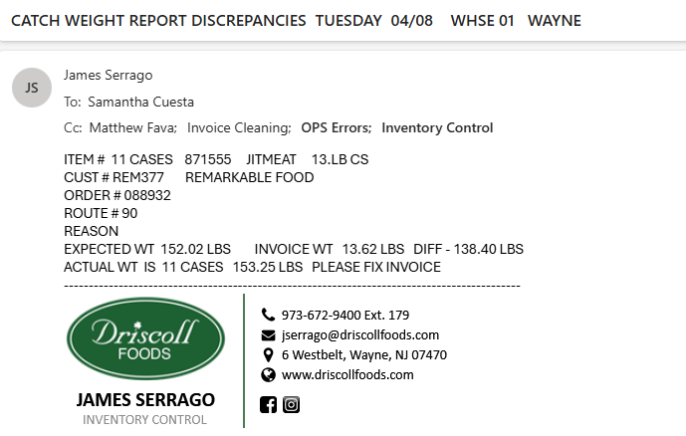
This report shows discrepancies, update the weights in telenet, to get exact weights on multiple case items go into Lucas for the day find the item on the order click on it and hit details at the top this should give you all the separate weights per case.
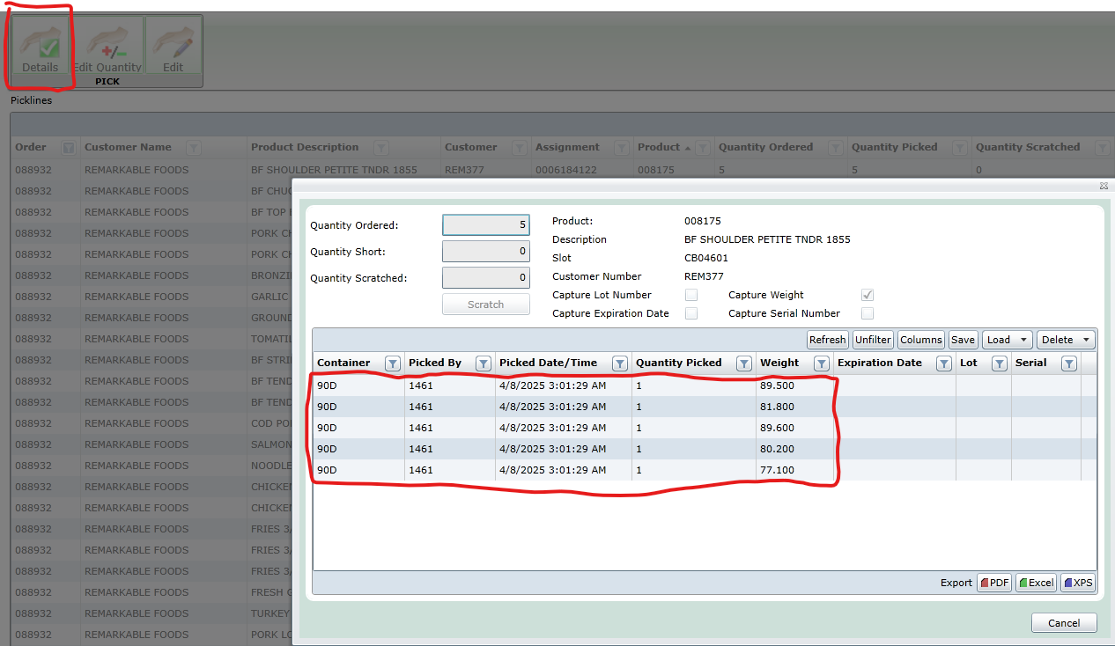
After these are updated print the new updated invoice and send it to the sales rep so they can forward it onto the customer.

p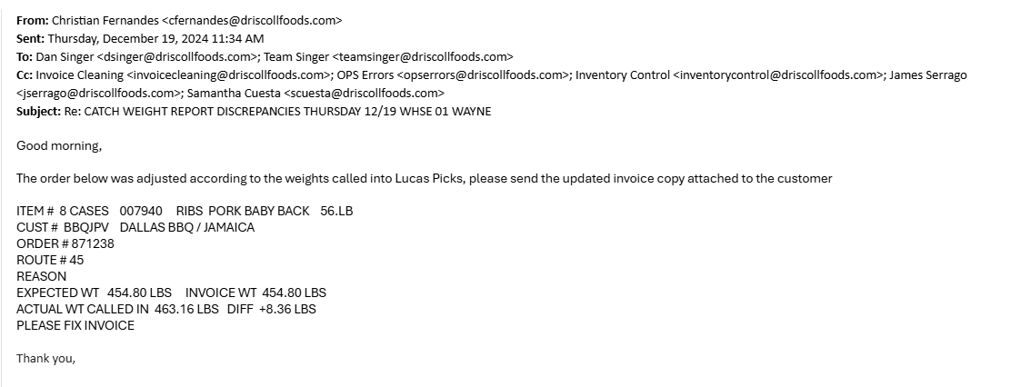
Good morning,

The order below was adjusted according to the weights called into Lucas Picks, please send the updated invoice to the customer

Blue bins
Go to Lucas picks, Warehouse, products type in the product number, click on the item line and hit edit then put the instructions in the proper lines as seen below

Make sure to pack this product in a blue bin with dry ice.
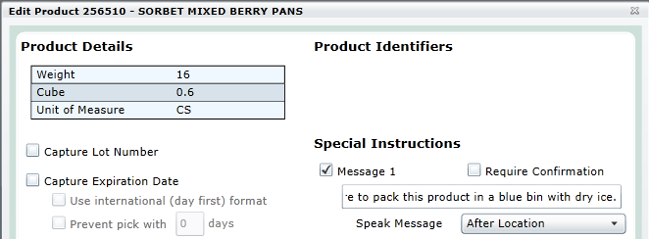

Fragile items
In Telnet go to 51 type in the item number go to page 3, type 3 hit enter, scroll down to fragile(Y/N) type in Y and hit enter.

Go to Lucas picks, Warehouse, products type in the product number, click on the item line and hit edit then put the instructions in the proper lines as seen below

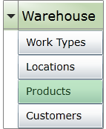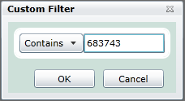

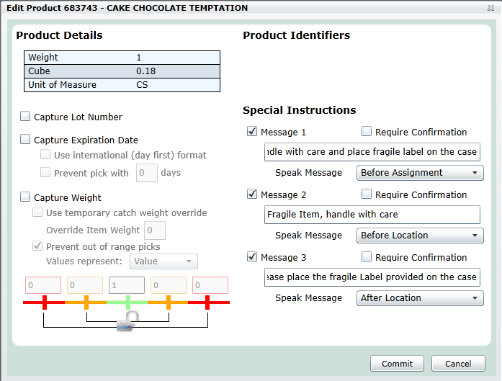

Weekly Ops Performance by Division
O:\Ops Management\Maintenance\Reports\KPIs
Use DUG14 to get the inbound cases for all 3 divisions use sum for a total for the week
Use DUG 16 to get the outbound cases and routes for all 3 divisions use sum for a total for the week

O:\Ops Management\Maintenance\Reports\Shorts and Mispicks\Weekly

Go to shorts and mispicks report for this week, use AMS errors, PA errors, and wayne errors to get short, shorts found later, mispicks, and damages for all 3 divisions. Use filter to filter down between the 4 reasons. Copy the qty short col paste at the bottom and use the sum function to get the total errors for that reason.

Use intellishift for the miles for NY and NJ
Data and reports, state milage
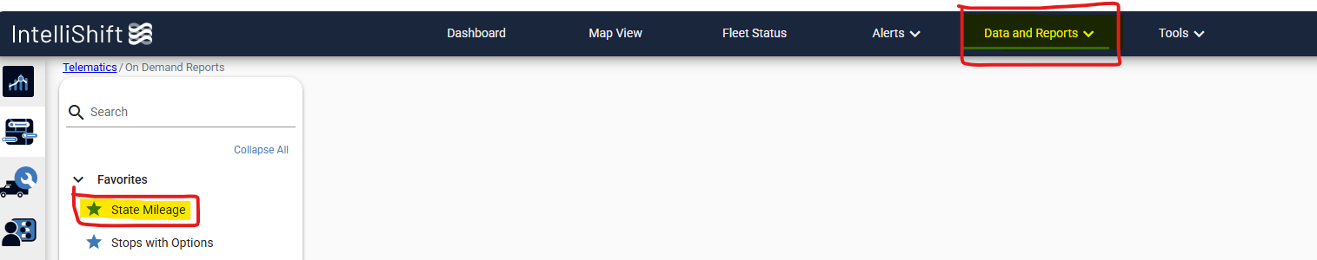
Use generate report by branch
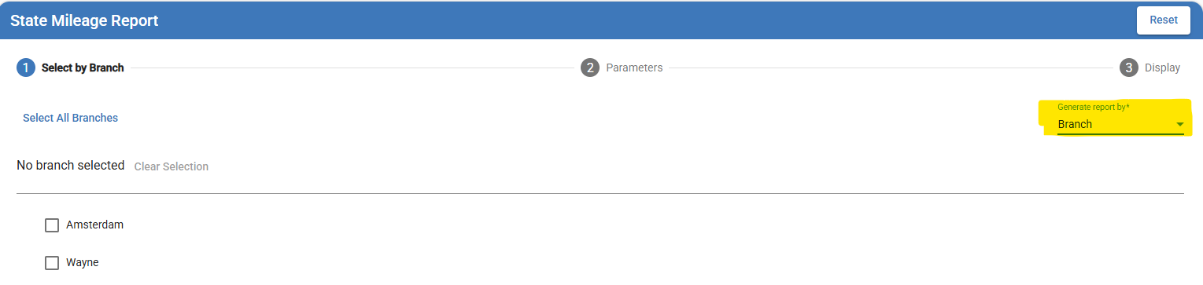
Run once for each branch, use the date for SUN-SAT of the week you are running, go to the last page to get the total miles.

Instructions for PA miles to be added later

Misaligned Invoice
Check other invoices from the same customer to see if this was a repeat issue or was caused by another issue with a different invoice or the printer being misaligned.
If this seems to be a 1 time thing reprint and send the invoice.

Two main reasons causing invoices to be misaligned
Customer file not being filled out properly, go to 37 use customer number to look it up and 01 for the second input.
If everything on that page looks okay and it is not an issue with an item on that or another invoice send the info to programming with a couple examples of invoices asking them to look into it.
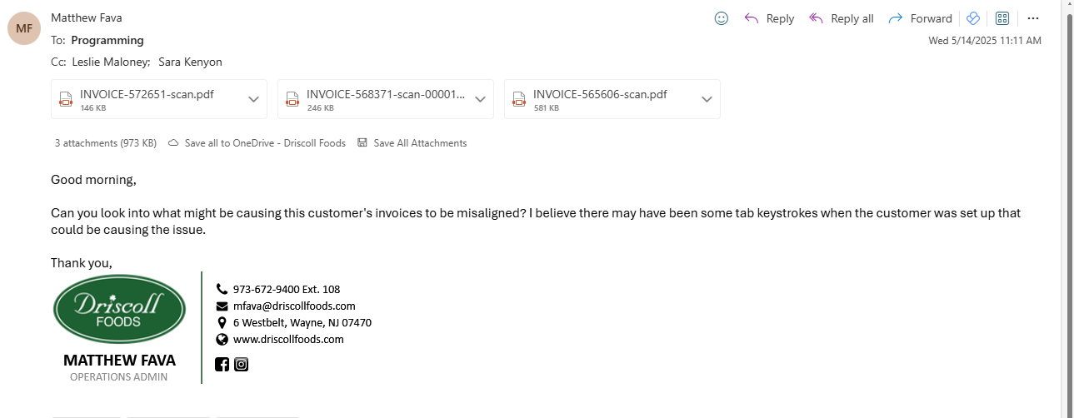

Do the same thing if it looks like an item that is the issue
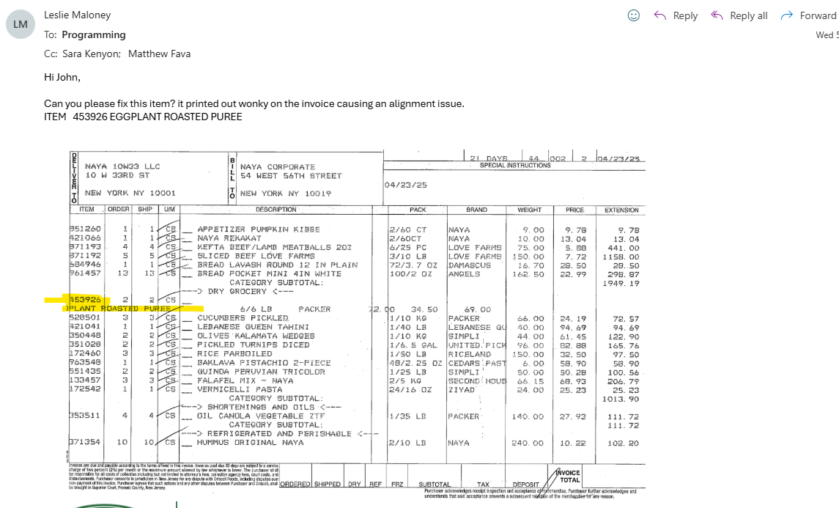

Credits Bids/Cumulative credits
DUG71VDT
X on the reasons menu
Shorts by Reason report
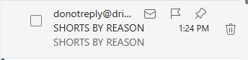
Filter the top row, filter COL Q by 03/MW/M8
Open Credits-CC file delete the last date on the report
On the shorts by reason report deleted dates up until the date deleted on the other report.

Remove columns QTY short, reason code, RT Group description, Pickeremployee, buyerbuyer short, extended costorder number
H, J, L-P, S-Z, AB-AF, AH-AJ
Paste all in info over to the other sheet, email to chris caselnova biddept@driscollfoods.com
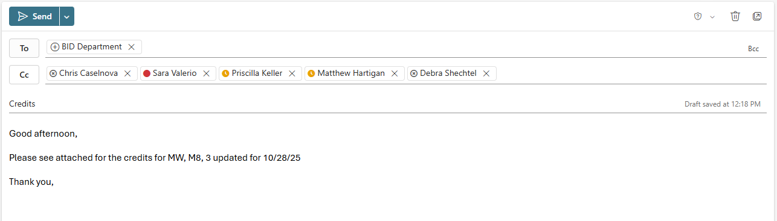

Sales groups:
Pandel: Pandelgroup@driscollfoods, Bill Kenney SR & JR, Mandy, Chris Pandel, Sandy Budhu, Stuart Lews, Alma Soto
H & H Camps: Nancy Cook, Grace Delli Santi

Lucas PIR Report
Filter Lucas picks col T by CG FS and DO add a column to the right of COL T and use formula below to pull out slot levels. Have 2 sheets one with levels 1,2,3 and the other with 0,4,5,6,7,8,9
Level pull out formula
=IF(IF(ISERR(RIGHT(T9708,1)*1),"letter","number")="letter",MID(T9708&" ",7,1),RIGHT(T9708,1))

Pivot table
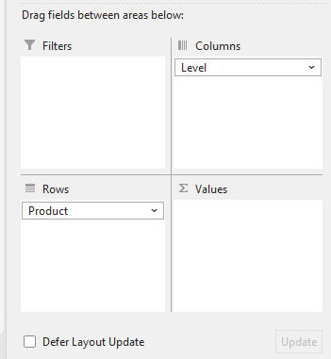
Use this to get the
Number of skus
Per level, highlight all of
Qty ordered and look at
The sum in the bottom
Right for the total cases

Lucas 3 and above report
Similarly to the Lucas PIR Report we are testing cases ordered first add a column next to the slot column, use this formula
=IF(OR(ISNUMBER(SEARCH("CG", T2)), ISNUMBER(SEARCH("FS", T2)), ISNUMBER(SEARCH("DO", T2))), "Remove", "Keep")
Filter to only have “Keep”
Use the Left function in excel to pll the first lett in the location cell filter3 tabs based on C for cooler, F for freezer, D for dry
Then use the same formula to pull the level
=IF(IF(ISERR(RIGHT(T9708,1)*1),"letter","number")="letter",MID(T9708&" ",7,1),RIGHT(T9708,1))
After this uncheck 1 and 2
Shorts & Mispicks Route J & I
When the shorts & mispicks report comes across filter the routes by those starting with J & I
Save and send to kudjoe, danny, shaun and CC sara
Any issues labeled driver send to Victor, Mike, Delareese, and CC sara
In this email copy and paste the error information in the body of the email.
Good afternoon,
Please see below for the shorts & mispicks for routes J & I for 8/25/25

Good afternoon,
Please see below for the shorts & mispicks for routes J & I for 8/25/25 noted driver
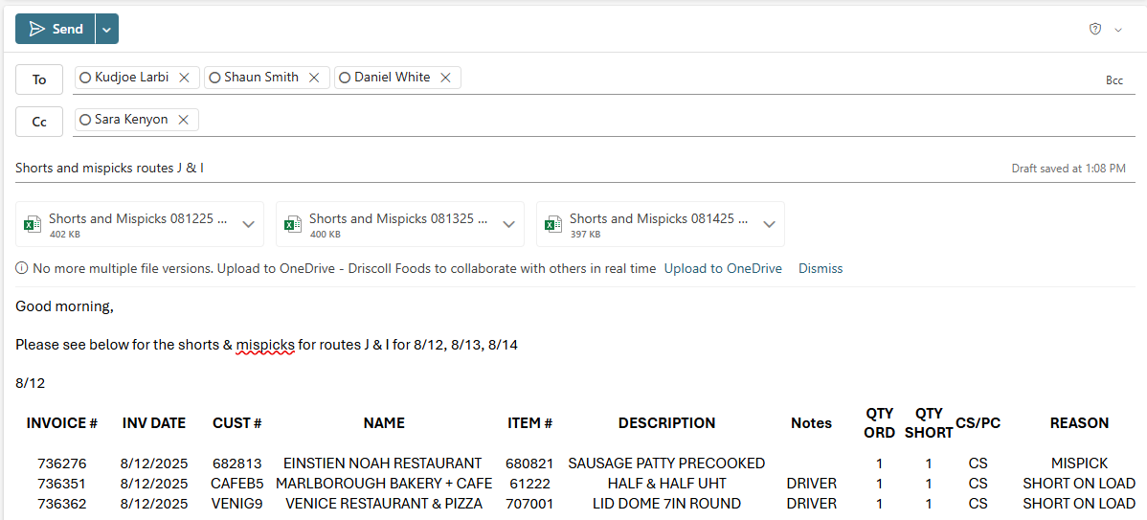

Shorts and mispicks by DSM
When the shorts and mispicks report comes across highlight all columns and create a pivot table. Use the fields screenshot below to make the pivot table. Send this to Sara
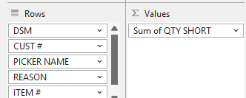
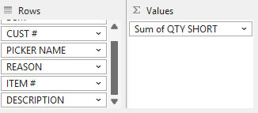

Lucas Batches not called in
Filter col Q of the Lucas report by blanks, For JITMEAT and JITSEA remove all PA and NY routes (below) remove JITOFFICE and JIT

PA IDs
P
R
S
N
O
NY IDs
G
W
Y
X
Z

Copy and paste all assignments by temp zone into a new tab use =count(unique,{col of data}) for the total batches not called in
Find a way to get all the unique batch values look at those values for every line make sure all items are not called in
Run the Lucas report for empty picked by, remove all rows with a number greater than 0 in quantity scratched and short. Filter by temp zone, copy all assignments use data tab in excel to remove all duplicated. Open the lucas report from the moring, look up all batches individually. Any assignments that have other items called in remove them from the list. Any that don’t have any items called in were not called in the batches were not called in
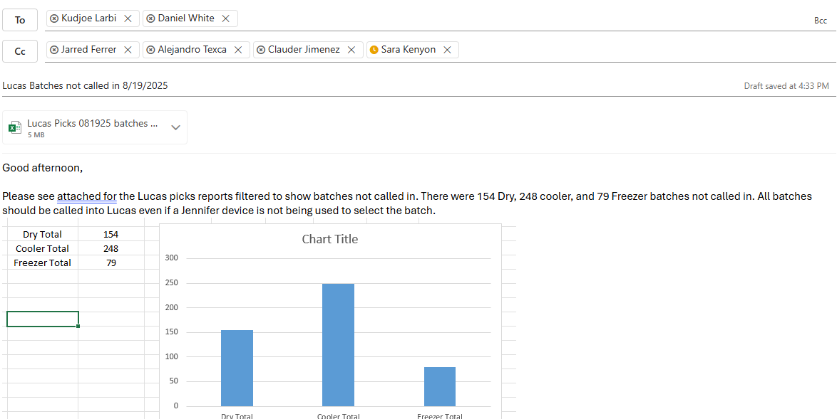
Good afternoon,
Please see attached for the Lucas picks reports filtered to show batches not called in. There were 154 Dry, 248 cooler, and 79 Freezer batches not called in. All batches should be called into Lucas even if a Jennifer device is not being used to select the batch.

Checker report
Cannot paste these formulas you have to rewrite them
For routes with number of pallets listed
=SUM(SUMIFS('Lucas Picks'!I82:I36377,'Lucas Picks'!M82:M36377,Sheet2!A81,'Lucas Picks'!N82:N36377,TEXTSPLIT(B81,",")))
For routes with Full written in
=SUMIF('Lucas Picks'!M38:M36849,Sheet6!A121,'Lucas Picks'!I38:I36849)
After separating by temp zone in the checker sheet, use these formulas based on Temp zone
=SUMIFS('Lucas Picks'!I2:I28545,'Lucas Picks'!M2:M28545,Sheet1!A4,'Lucas Picks'!P2:P28545,"Refer")
=SUMIFS('Lucas Picks'!I27:I28570,'Lucas Picks'!M27:M28570,Sheet1!A29,'Lucas Picks'!P27:P28570,"Dry")
=SUMIFS('Lucas Picks'!I46:I28589,'Lucas Picks'!M46:M28589,Sheet1!A48,'Lucas Picks'!P46:P28589,"Freezer")
M col is routes, I is qty picked, N is stops sheet2!A# is the cell in col A for this row
You will need the checking sheet, Pallet summary sheet and Lucas Pick from the date you are running this report for.

On the checking sheet filter so that the first checker name column has no blank cells, add another column after use a vlookup using the route as the comparison to the pallet summary sheet to get the total orders for that route.
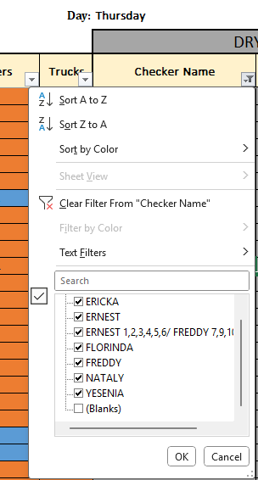
ignore
Open Lucas, filter only by Full Routes, copy route to work type, delete stop column highlight all of the pallet column delete duplicate data highlight all, pivot table
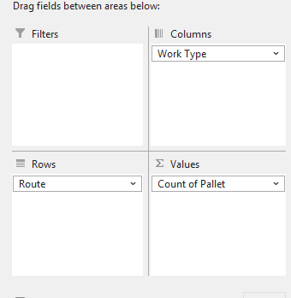
Copy all full routes two extra times one for each zone, copy checkers into sections below, paste over the amount of pallets per temp zone
=LEN(D8)-LEN(SUBSTITUTE(D8,",",""))+1 count non full cells

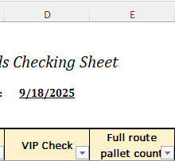
For the routes with numbers i.e 1,7 5 1,2,3. Count the number of orders the previous example would be 2 1 3 and write them in that new column.
Next look for any with split checkers on the route
In this example ernest would get 6 and freddy would get 5
Create a pivot table data source should look something like this, make sure to include the selectors names. Once the pivot table is created it should have only the checkers name and the number of orders
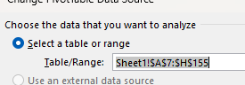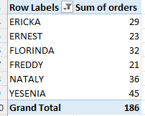
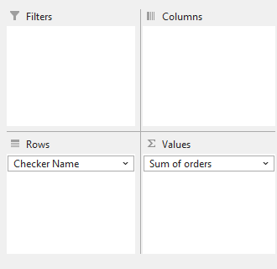
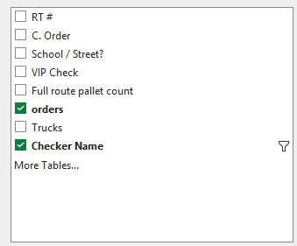

Add these numbers to the Checker report.
Open the Lucas picks report copy the route column and vip check column into a second tab in the Lucas picks report. Now use the two formulas at the top of this section if the column as numbers of pallets listed use the first formula if it says full use the second formula. Using a vlookup with route as the comparison point get the selector names next to the case numbers.
Now make a pivot table with the names and cases columns, and put these numbers into the checker report
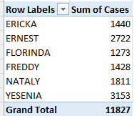
After each day copy all the checker names and paste them into the sheet titled “Checker” along with the day of the week. On Friday take all of those names refresh the pivot table with the one week of names paste those into the weekly tab
Email
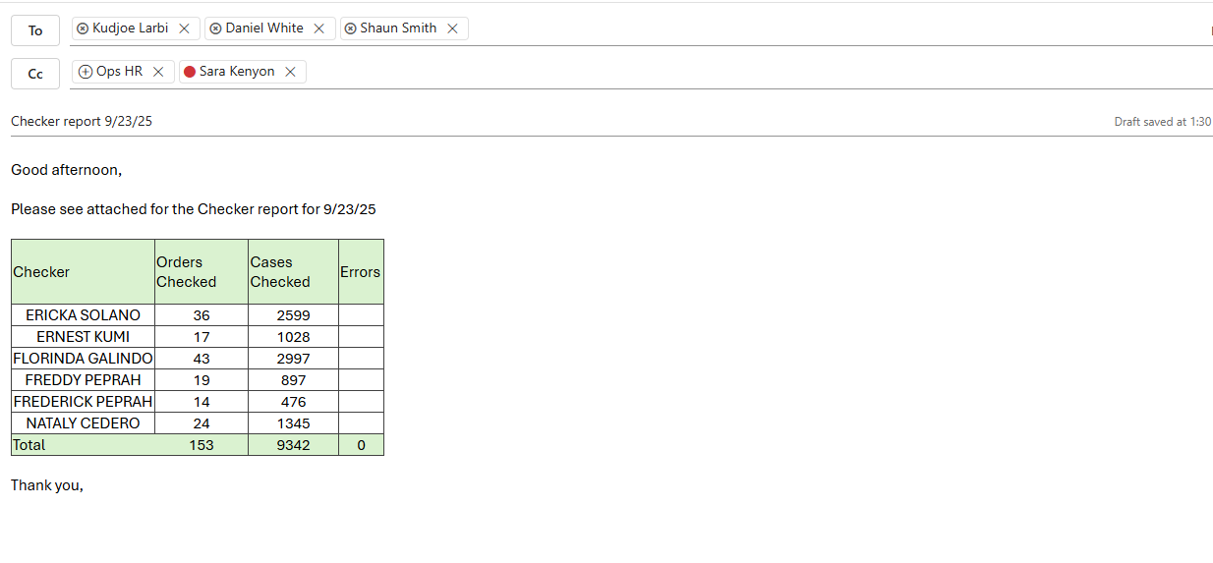

Night selectors batch times
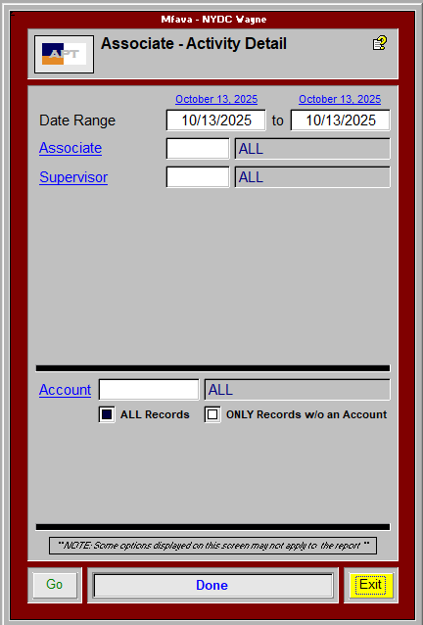

Route J & I errors
Runs shorts by reason report, filter for routes J & I filter out sales errors

